Supplementary information

 | PO (Rev 2) |  |  |  | PO (Rev 3) |  |  |  | PO (Rev3)
PO (Rev 1) | Group 1 | Group 2 | Total | PO (Rev 1) | Group 1 | Group 2 | Total | PO (Rev 2) | Group 1 | Group 2 | Total
Group 1 | 406 | 3 | 409 | Group 1 | 405 | 4 | 409 | Group 1 | 410 | 7 | 417
Group 2 | 11 | 2 | 13 | Group 2 | 9 | 4 | 13 | Group 2 | 4 | 1 | 5
Total | 417 | 3 | 422 | Total | 414 | 8 | 422 | Total | 414 | 8 | 422
Measures | Estimates | 95% CI |  | Measures | Estimates | 95% CI |  | Measures | Estimates | 95% CI
Accuracy | 0.97 | 0.94–0.98 |  | Accuracy | 0.97 | 0.95–0.98 |  | Accuracy | 0.97 | 0.95–0.99
Table S1. Comparison of pedicle screw assessment in Group 1 and 2 by all reviewers. (Rev1, Rev 2, Rev 3) from IO and PO images and their accuracy.
 | IO (Rev 2) |  |  |  | IO (Rev 3) |  |  |  | IO (Rev 3)
IO (Rev 1) | Group 1 | Group 2 | Total | IO (Rev 1) | Group 1 | Group 2 | Total | IO (Rev 2) | Group 1 | Group 2 | Total
Group 1 | 408 | 1 | 409 | Group 1 | 405 | 4 | 409 | Group 1 | 414 | 5 | 419
Group 2 | 11 | 2 | 13 | Group 2 | 12 | 1 | 13 | Group 2 | 3 | 0 | 3
Total | 419 | 3 | 422 | Total | 417 | 5 | 422 | Total | 417 | 5 | 422
Measures |  | 95% CI |  | Measures | Estimates | 95% CI |  | Measures | Estimates | 95% CI
Accuracy | 0.97 | 0.95–0.99 |  | Accuracy | 0.96 | 0.94–0.98 |  | Accuracy | 0.96 | 0.94–0.98

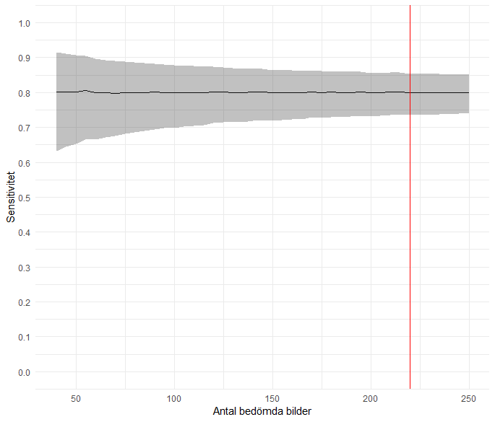
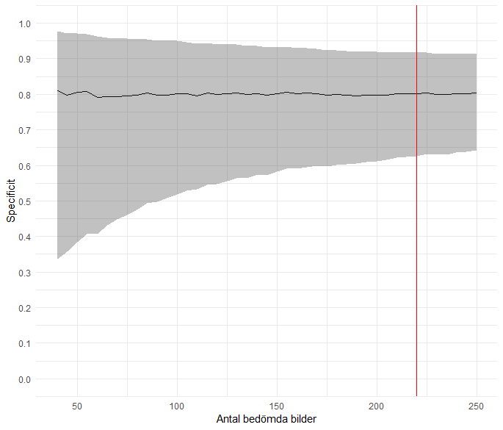
Number of screws
Number of screws
Specificity
Sensitivity
Figure S1. (Right) Predicted confidence interval of the sensitivity of the assessment of pedicle screw positions from IO images as a function of the number of screws included in the study. (Left) Predicted confidence interval for the specificity of the assessment of pedicle screw positions from IO images as a function of the number of screws included in the study. The red horizontal line marks the selected sample size (n=220).

