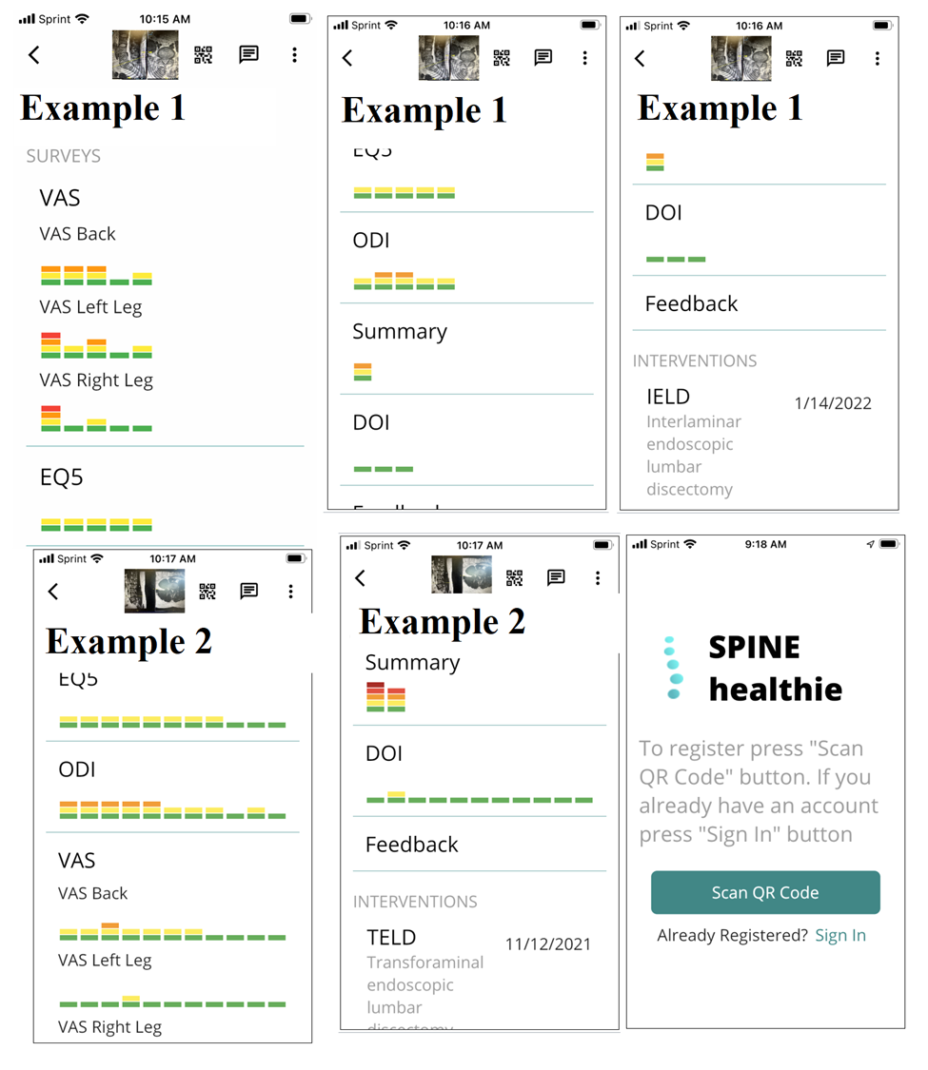**Supplemental Figure 1.** Sample of mobile application features used to track pain and functional outcomes in two example patients. As illustrated, this mobile application will track VAS and ODI outcomes at distinct timepoints in real-time following survey completion. Patients are able to download this application following study enrollment and account creation via a QR code generated by the research team.